The Effects of Different Burning Treatments on the Amount of Canopy Cover

Abstract :
This study concerns fire management strategies and their efficiency in reducing amount of canopy cover produced by the ponderosa pine species. We analyzed three distinguished plots that were administered with three different treatments such as just thinning trees, burning trees, and thinning and burning trees. There was also included a fourth control plot in which no treatment was administered. We analyzed the each of differently treated plots for percent of canopy cover. We found that the burning treatment provided the most effective results in reducing canopy cover.

Introduction:
The dense populations of the ponderosa pine pose a threat to wildlife species diversity and human settlements. Due to such course of concern, several fire management strategies were tested for their efficiency to control the density of the ponderosa pine species and reducing canopy cover. Understory species compete for resources such as light with these tall trees. The amount of light available to these species on the ground depends on the amount of canopy cover produced by the trees towering over the species closer to the ground. Also, the spread of crown fires disturbs populations of wildlife as it spreads so rapidly. Such disturbance can lead to devastating effects to both wildlife species living in the forest habitat and human settlements nearby. Ways to reduce this rapid accumulation of fire is to reduce the fuel load. Reducing the fuel load consequently reduce the the severity of the fire(Shang, He, Crow and Shifley, 2004). Several methods to go about this process are by thinning the forests, directly prescribing fire treatment to burn distinguished plots, or thinning and burning plots. Reducing the fuel load with just thinning will prevent the fires from accumulating in terms of severity. As seen in one study, plots with most reduction of fuel load resulted in lowest severity in case of wildfires(Agee and Skinner, 2015). Thinning and then burning of forests will lead to further reduction of fuel load. However, the method of directly burning the plots will also be efficient in the case of very dense populations which increase fuel load(Pollet and N. Omi, 2002). The spread of a fire is directly correlated to the amount of fuel load available. We hypothesized that thinning and burning will lead to the most effective reduction of canopy cover.

Materials and Methods:
There are three treated plots and a control plot that were surveyed on Lindsey Property. These designated plots consisted of the ponderosa pine species receiving different burn treatments. The plots examined showed unique density of ponderosa pine forests. The control plot that received no treatment conveyed the most dense forest. The plot that received the burning treatment had the least amount of poderosa pine density. The plot that received the thinning treatment had a higher density than that of the burning and thinning treatment plot but less dense than the reference plot. The burning and thinning treated plot yielded forest of density higher than the burning treatment and less than the thinning treatment. To perform this study, canopy cover was measured using the canopy cover app. After setting up 10 transects in each plot, we established three random distances from the edge of each transect to survey canopy cover. This randomization of distance allowed more genuine data. We walked over to the determined distances and surveyed canopy cover in the plots with the app. Then, we noted down the percent of canopy cover present in that specified area. This same process was performed for each transect established in each plot. After gathering all the data we used R software to compute the Anova results of the study.

Results:
Amount of fuel load available drastically affected the effects of each fire treatment. The burning treatment produced the most effective results with least amount of canopy cover present in the plot. The amount of degrees of freedom was 3 indicating the reliability of the data collected. The data we collected was genuine due to the p-value being less than 2e-16. Results also showed that the most amount of difference in canopy cover was between reference and the burn treatment(.44747%). This indicates that the burn treatment was the most effective in reducing canopy cover as opposed to the other treatments. Figure 1 depicted below portrays the results of the study. The highest percent of canopy cover was present in the reference plot followed by the thinning and burning plot, then the thinning plot, and then the burning treated plot with the lowest amount of canopy cover as depicted in the graph below(figure 1).

Figure 1
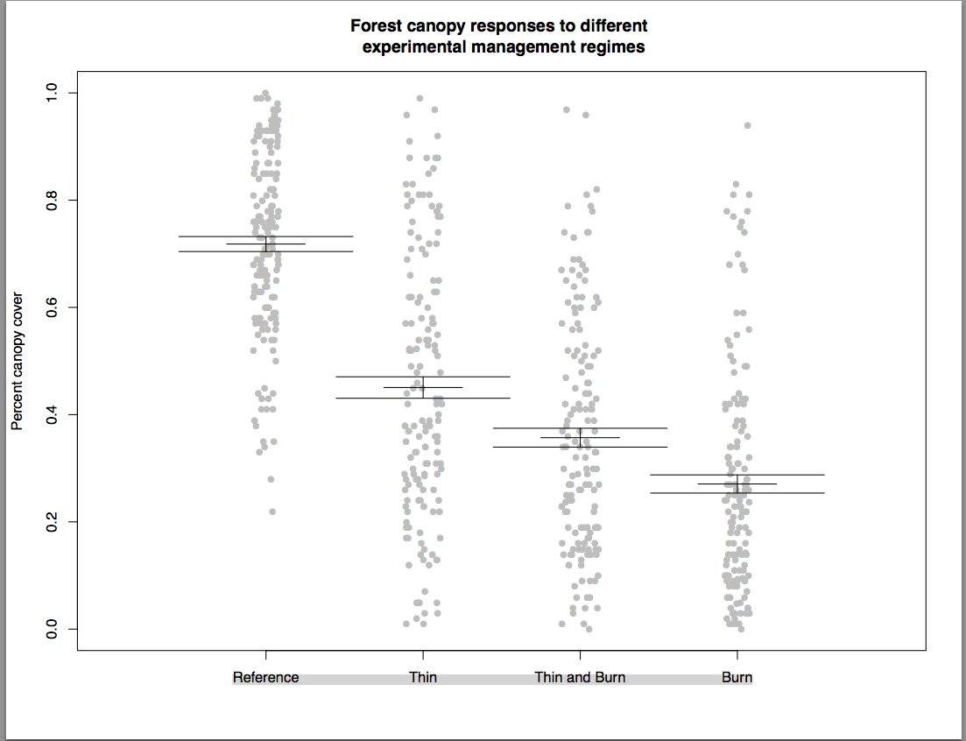This graph shows the percent of canopy cover present with each of the different burn treatments.

Discussion:
The study concluded our hypothesis of thinning and burning to be most effective in reducing canopy cover was wrong. In contrast, the most effective method to reducing canopy cover was to burn the forests. When thinning and burning, the amount of fuel load was significantly decreased so fire didn't spread too well. However, controlled burning of dense forests without thinning proved to be very effective. Agee and Skinner's study determined that higher density patches have resulted in higher severity fires( Agee and Skinner). This further validates the results that the burning treatment was the most successful in reducing amount of canopy cover. The study didn't support the hypothesis that burning and thinning treatments would be most effective. However, the results do yield a logical resolution. With the increased amount of fuel load in the plot as opposed to when they are thinned, the plots burn quicker with the fire being able to spread. What wasn't examined in this study is the rate of regrowth of the trees after each treatment. Such results could determine if any treatments would be most effective in reducing canopy cover, but may facilitate regrowth of the population of trees. This can be studied by examining the previous fire management plots that used similar treatments and recording what the canopy cover was before the treatment and 20 years after the treatments were administered and the plots are repopulated.

References:

Pollet, Jolie, and Philip N. Omi. "Effect of Thinning and Prescribed Burning on Crown Fire Severity in Ponderosa Pine Forests."International Journal of Wildland Fire11 (2002). Print.

K. Agee, James, and Carl N. Skinner. "Basic Principles of Forest Fuel Reduction Treatments."Forest Ecology and Management 211.1-2 (2005). Print.

Z. Shang, Bo, Hong S. He, Thomas R. Crow, and Stephen R. Shifley. "Fuel Load Reductions and Fire Risk In Central Hardwood Forests of the United States: A Spatial Simulation Study."Ecological Modelling 180.1 (2004). Print.

